**1. Sign up steps - progressive disclosure**

Instead of overwhelming users with a long form, it breaks the process into two easy steps. First, you simply enter your email address or log in with your preferred social media account. Once you click “Next,” you’re presented with a second, smaller form to create a password. This interactive approach keeps users engaged and focused, making the sign-up process a piece of cake.

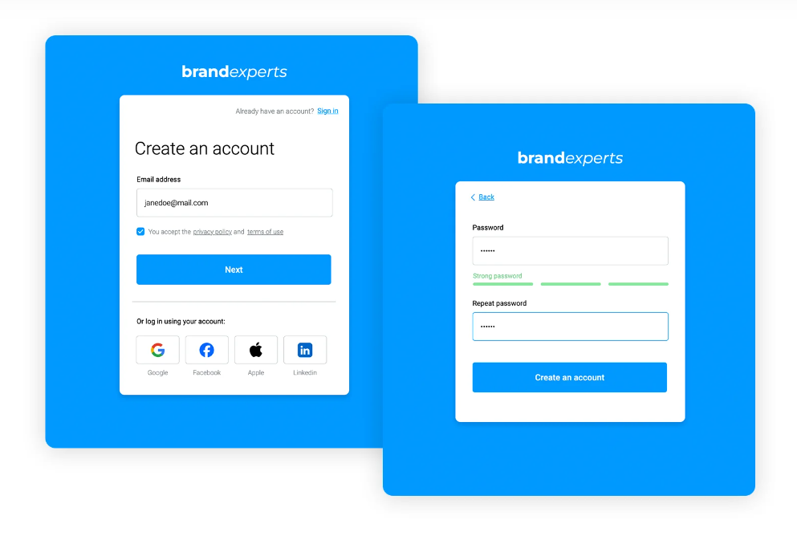

**2. Free design webs summit - anchored website navigation**

When you click on a link, like “Presentation” or “Schedule,” the page automatically scrolls down to that section. It’s a straightforward way to navigate and find the information you need

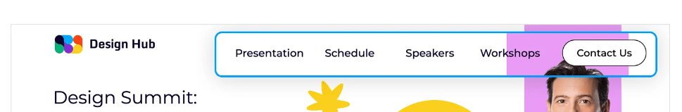

**4. E-learning website example - classic head website navigation**

This wireframe demonstrates a timeless navigation menu for an e-learning website. The menu bar features a simple design with four essential links: “Home,” “Event,” “Members,” and “About.” This classic layout is easy to navigate and understand, making it a great choice for websites that prioritize a clean and user-friendly experience

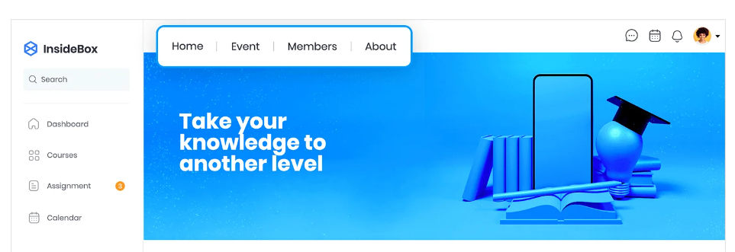

**5. Angular HR web app template - side menu**

This is a side menu with subcategories for an Angular HR web app template. It has a clear title, “HR Acme,” and a list of main categories that you can click on to see more options. It’s a great way to keep everything organized and easy to find.

